5. Celtic knots I
Website : www.theedkins.co.uk/jo/u3acpatt
www.theedkins.co.uk/jo/knots

Felt-tip pen method:
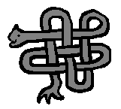
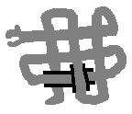



Use a thick, pale coloured felt-tip pen (high-lighters are good) and a thin, dark felt-tip pen.

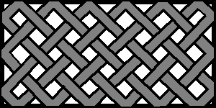
Free-form:


Celtic knots have
sloping lines.
It helps to draw
a guide box.

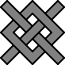



Heraldic knots:


Stafford Savoy Bourchier Wake Harrington

Combine any of these knots to make a complex Celtic knot.



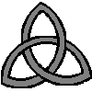


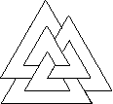
Topological knots: These are continuous (no ends)



Bowen Solomon Trefoil Cinquefoil Borromean rings Valknut

Examples from manuscripts:
Durham Gospels late 7C (Celtic / Anglo-Saxon)
Lindisfarne Gospels 700 AD (Celtic / Anglo-Saxon)
Book of Kells 800 AD (Celtic / Anglo-Saxon)

