7. Shapes
Website : www.theedkins.co.uk/jo/u3acpatt
www.theedkins.co.uk/jo/angle/shape.htm
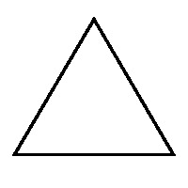
www.theedkins.co.uk/jo/solid
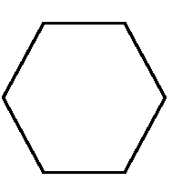
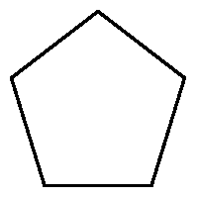
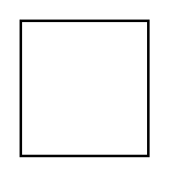

Triangle (3) Quadrilateral (4) Pentagon (5) Hexagon (6)
total:180° reg: 60° total:360° reg: 90° total:540° reg: 108° total:720° reg: 120°
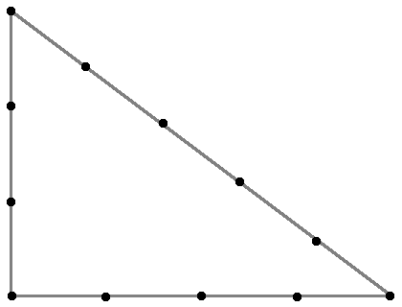
Pythagoras’ theorem: To get a right angle (90°) , use circle of rope with 12 equally spaced knots. Pull apart at 3rd, 7th and 12th.
Sides of triangle are 3,4,5. Right angle because 3x3+4x4=5x5.
Triangle 5,12,13 also works.
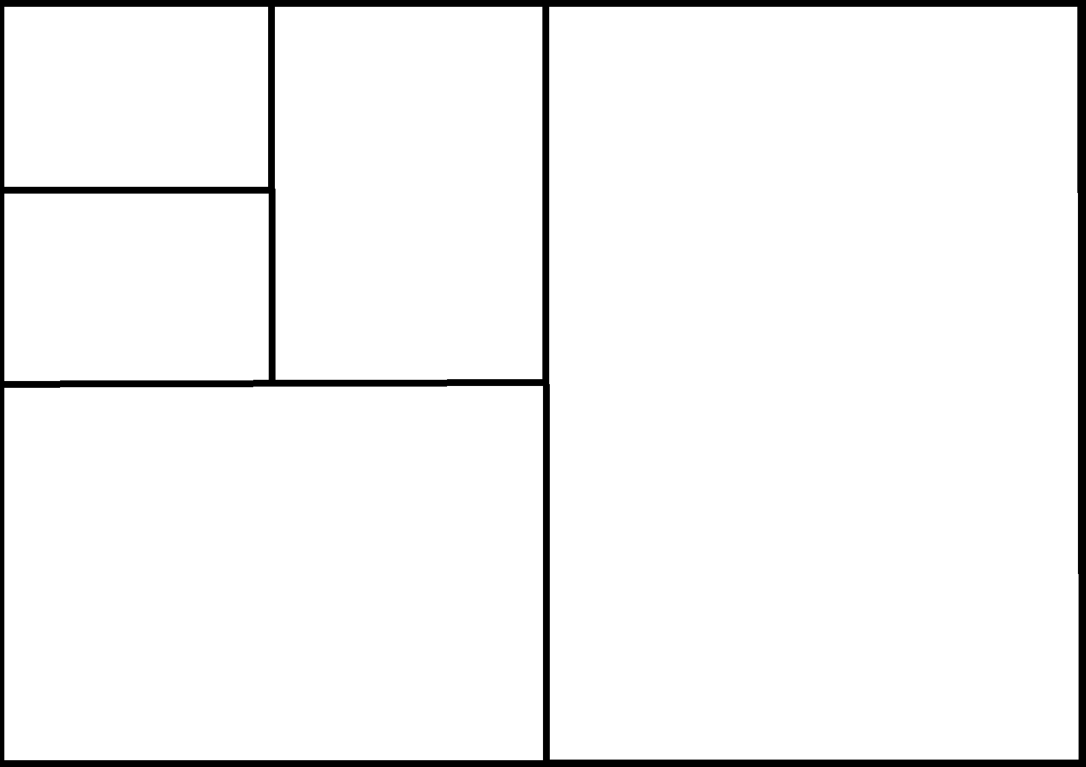
A4 etc: Fold A4 in half to get A5, and again to get A6, etc.
These are all the same shape.
This does not necessarily happen with rectangles.
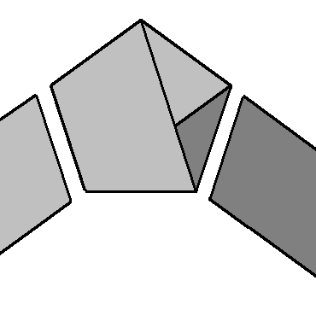
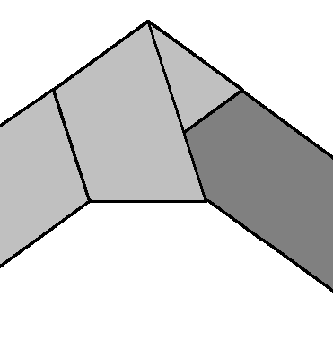
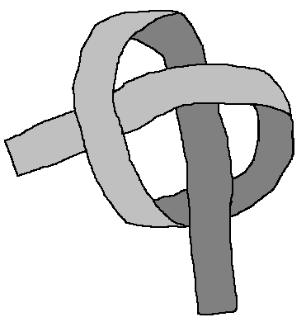
Make a pentagon from paper:
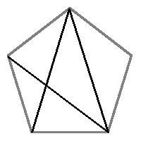
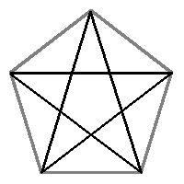
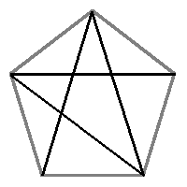
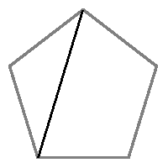
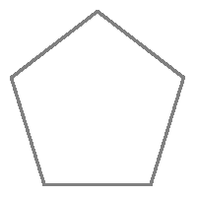
Star:

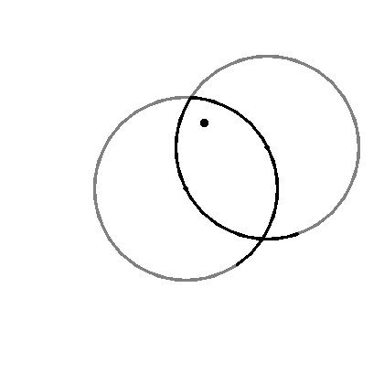
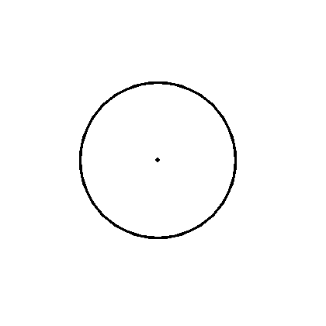
Draw a hexagon (flower and fish):
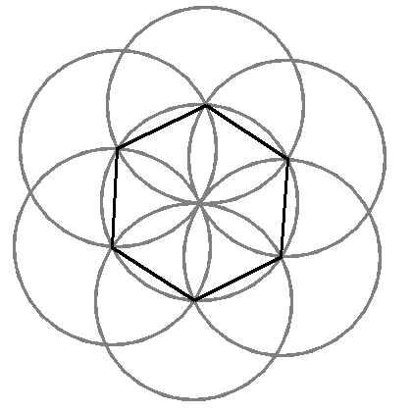
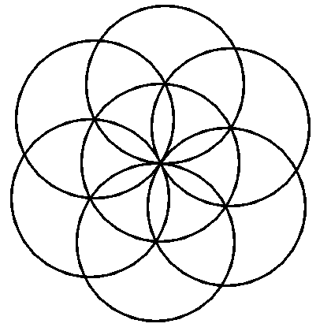
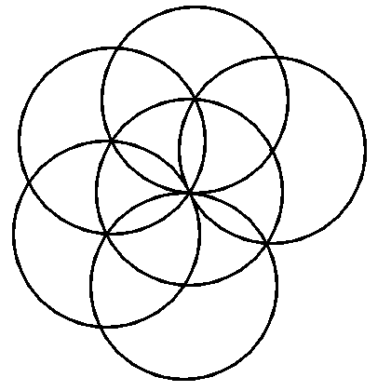
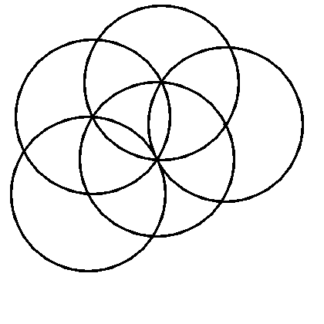
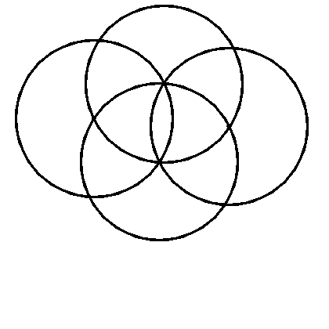
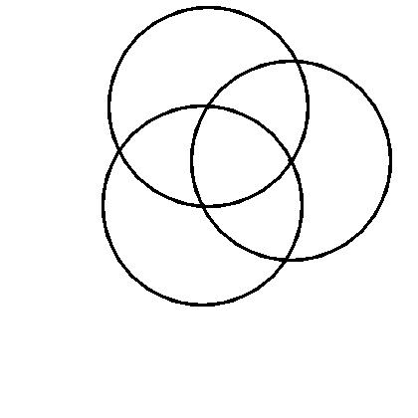
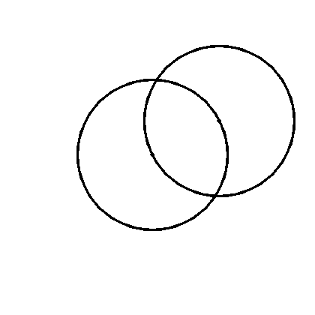
Examples:
Gorham's Cave near Gibraltar, Neanderthal, at least 39,000 years old (diamonds)
Ness of Brodgar, Orkney, Neolithic, ~3,000-2,500 BC (diamonds and triangles)
Skara Brae, Orkney, Neolithic, ~3,000-2,500 BC (rectangles)
Stonehenge, Wiltshire, ~2,500 BC (circles and rectangles)
Corded Ware pottery, Germany, ~2,500 BC (triangles)
Pyramids at Giza, Egypt, ~2,500 BC (triangles on square base)
Parthenon, Athens, 438 BC (rectangles and triangular pediment)
Colosseum, Rome 80AD (circle, rounded arches)
Chapter House, York Minster, 1290 AD (pointed arches)

