8. Symmetry
Website : www.theedkins.co.uk/jo/u3acpatt
www.theedkins.co.uk/jo/symmetry
https://www.theedkins.co.uk/jo/symmetry/drawsymm.htm
Reflective: symmetry about a line
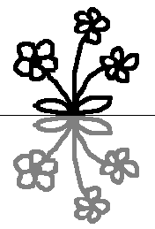
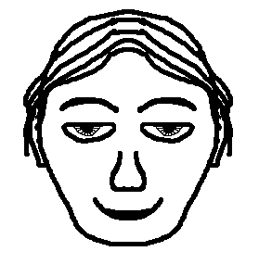
Vertical line of symmetry (mirror) Horizontal line of symmetry (flip)

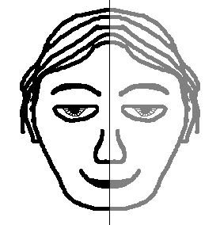

2 lines of symmetry 3 lines of symmetry (3 not 6!) 6 lines of symmetry
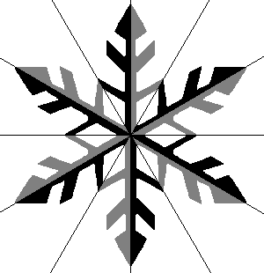
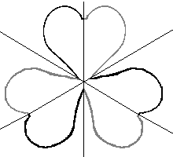
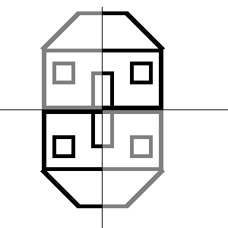

Rotational: symmetry about a point
Turn one bit to make the pattern
Try with face: -
Perhaps not!

Good example of 2 way rotational symmetry is double spiral

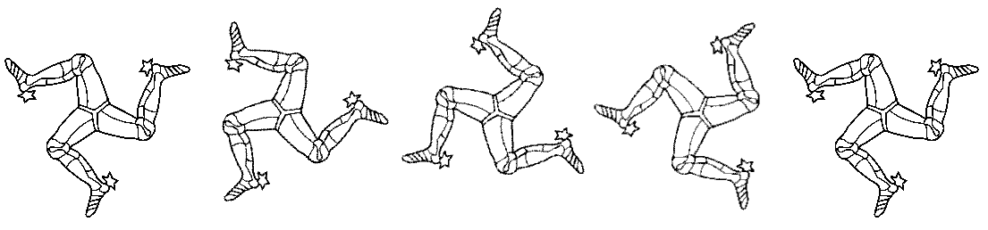
Example of 3 way rotational is triskelion (from Isle of Man) – no lines of symmetry!

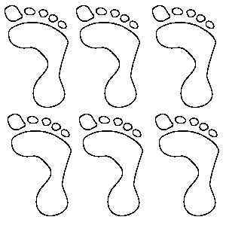
Translation: repeated pattern
Don’t reflect, don’t turn,
Just repeat!

