9. Tessellations
Website : www.theedkins.co.uk/jo/u3acpatt
www.theedkins.co.uk/jo/tess
www.theedkins.co.uk/jo/tess/drawmos.htm
www.theedkins.co.uk/jo/tess/drawtess.htm

Angles at a point must add up to 360°. Use colour to make patterns, even in simple shapes.

6 triangles round a point 4 squares round a point
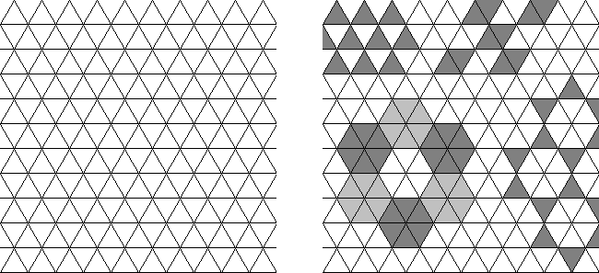
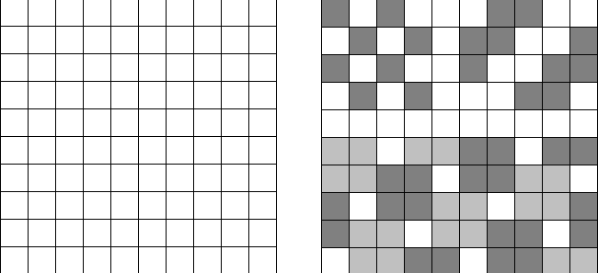

3 hexagons round point Combinations of shapes
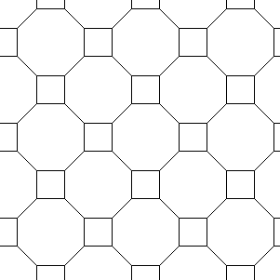
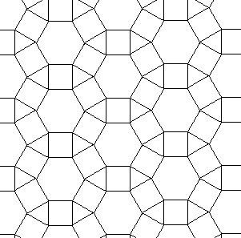
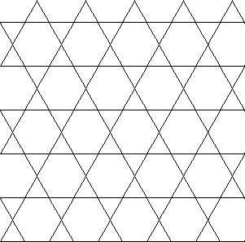
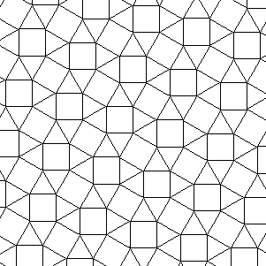
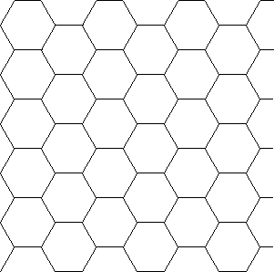

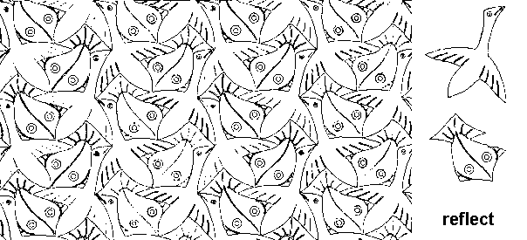
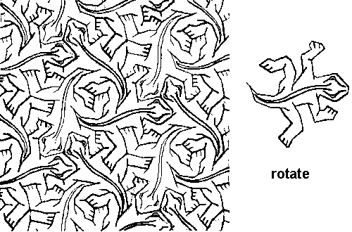
Complicated shapes can also tessellate

Geometric tiles covering a flat surface with no overlaps and no gaps is a tessellation.
Islamic decoration made from geometric tiles set into plaster is called zellige.
Mathematical term: wallpaper group - flat repetitive pattern, based on the symmetries in the pattern. These occur frequently in decorative art. There are 17 possible distinct groups.

Examples:
Islamic examples are from approx 15C.
Alhambra, Spain (inspired M.C.Escher)
Bibi Khanum Mosque, Samarkand, Uzbekistan
Shah Nematollah Vali Shrine, Mahan, Iran
M.C.Escher: Dutch graphic artist (1898-1972) who made mathematically inspired pictures

